# **Data Visualization**

Generating visualizations makes it clear for the user to understand the analysis of the data, hence we have generated certain graphs and visualizations to make our ideas seamless for the users to follow:

## **How the number of tickets given changes with each month?**

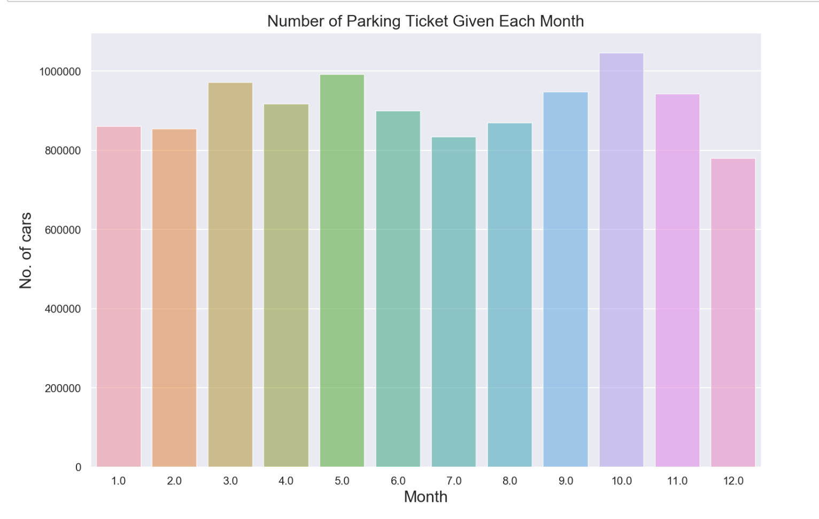

Figure 19: Tickets each month

## **Parking tickets are given for each violation code and violation codes:**

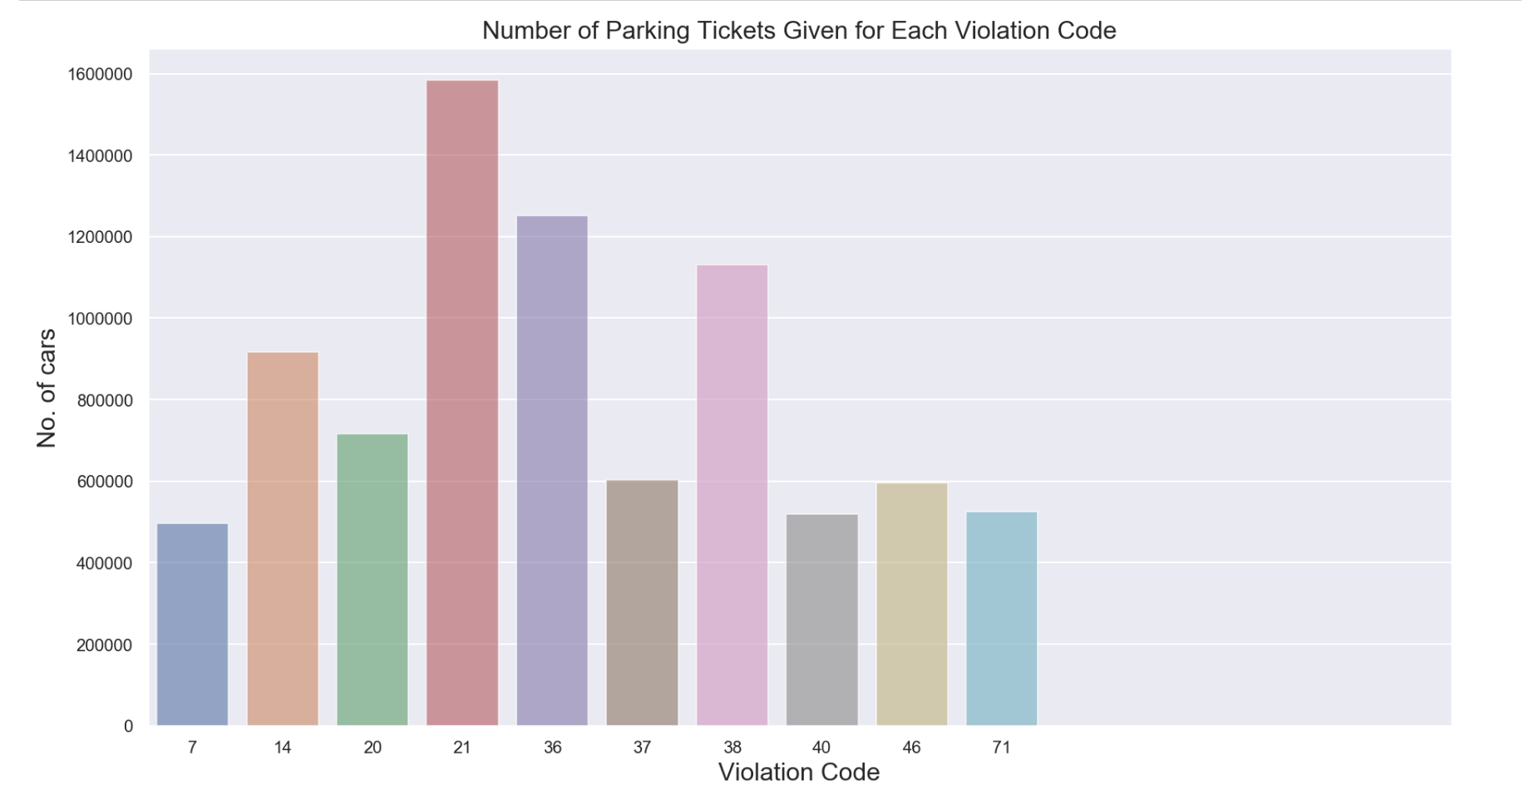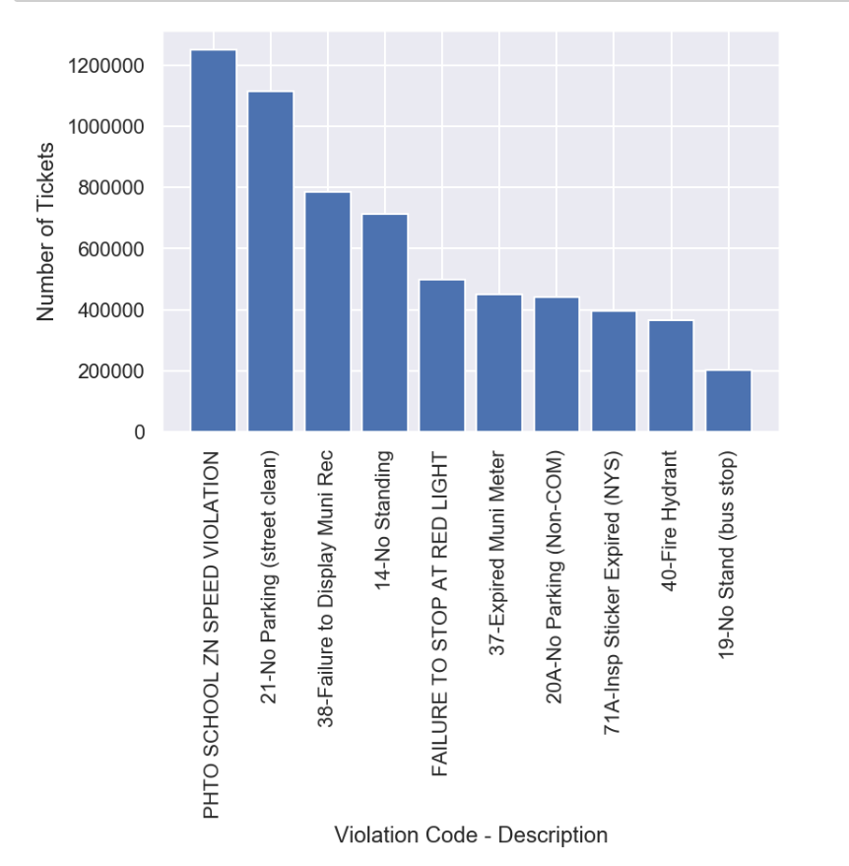

## 

Figure 20: Visualization by violation codes

## **Vehicle Year and Ticket count:**

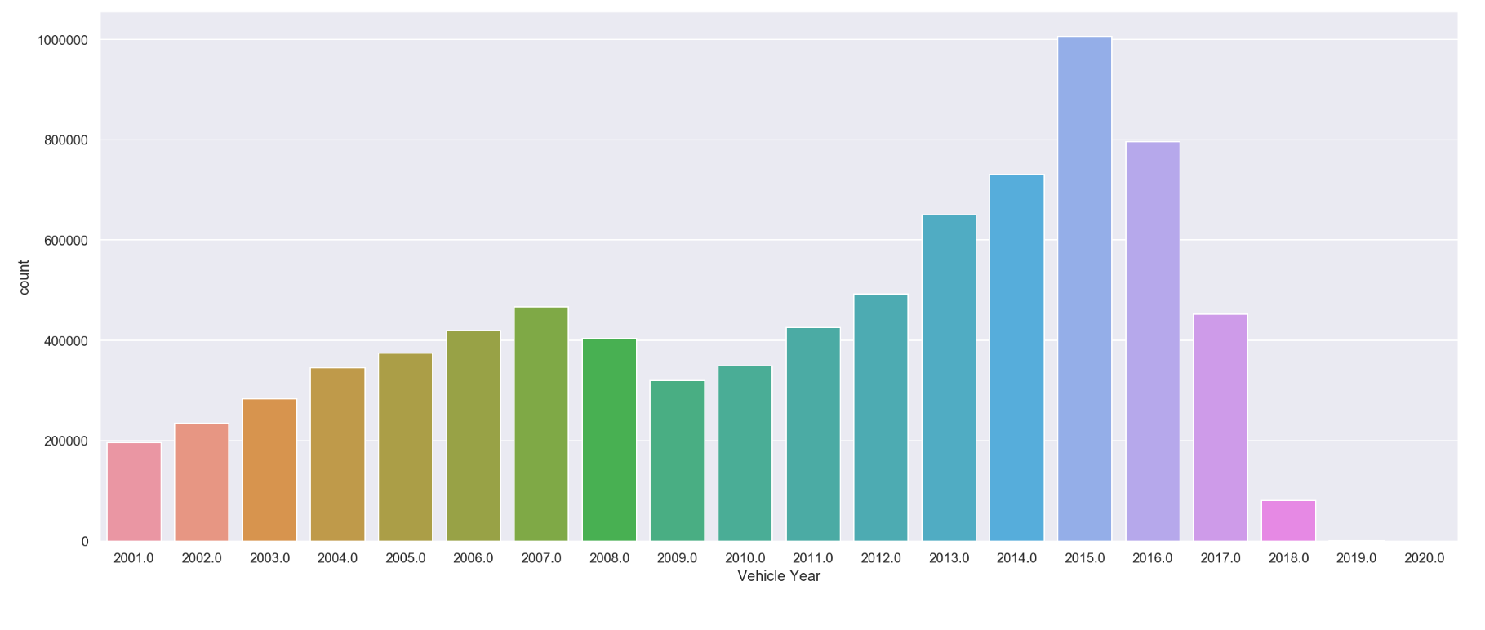

Figure 21: Ticket count by year